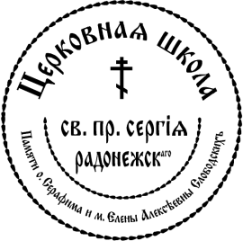

Returning
2019/2020

#1 Child’s Name _____ DOB: _Namesday__________

#2 Child’s Name DOB_________Namesday_____________

#3 Child’s Name DOB_________Namesday_____________

#4 Child’s Name DOB_________Namesday_____________

#5 Child’s Name DOB_________Namesday_____________

Mother Father

Name : __ __________________

Cell phone : _______ _______________

Email :________________________________ _____________________________________

Check # ___________ Check Amount __________ Cash Amount__________

Assembly Fee:
$450 for the first child
$250 for the second child
Please make check payable to: “Tolstoy Foundation, Inc.”
Memo: “Assembly Fee”

I have read and signed the Rules of Conduct and will adhere to them.

__________
Parent’s Signatures Date

St. Sergius Learning Center•104 Lake Road, Valley Cottage, New York 10989 845-268-2037

